For paper #2
Please reread again the prompt, so you can understand more what the prompts ask you about
Also, do not forget to use “Insert Footnote” Function for the citing quotes. The quote must be following the “The Chicago Manual of Style method.” See the instruction on how to quote.

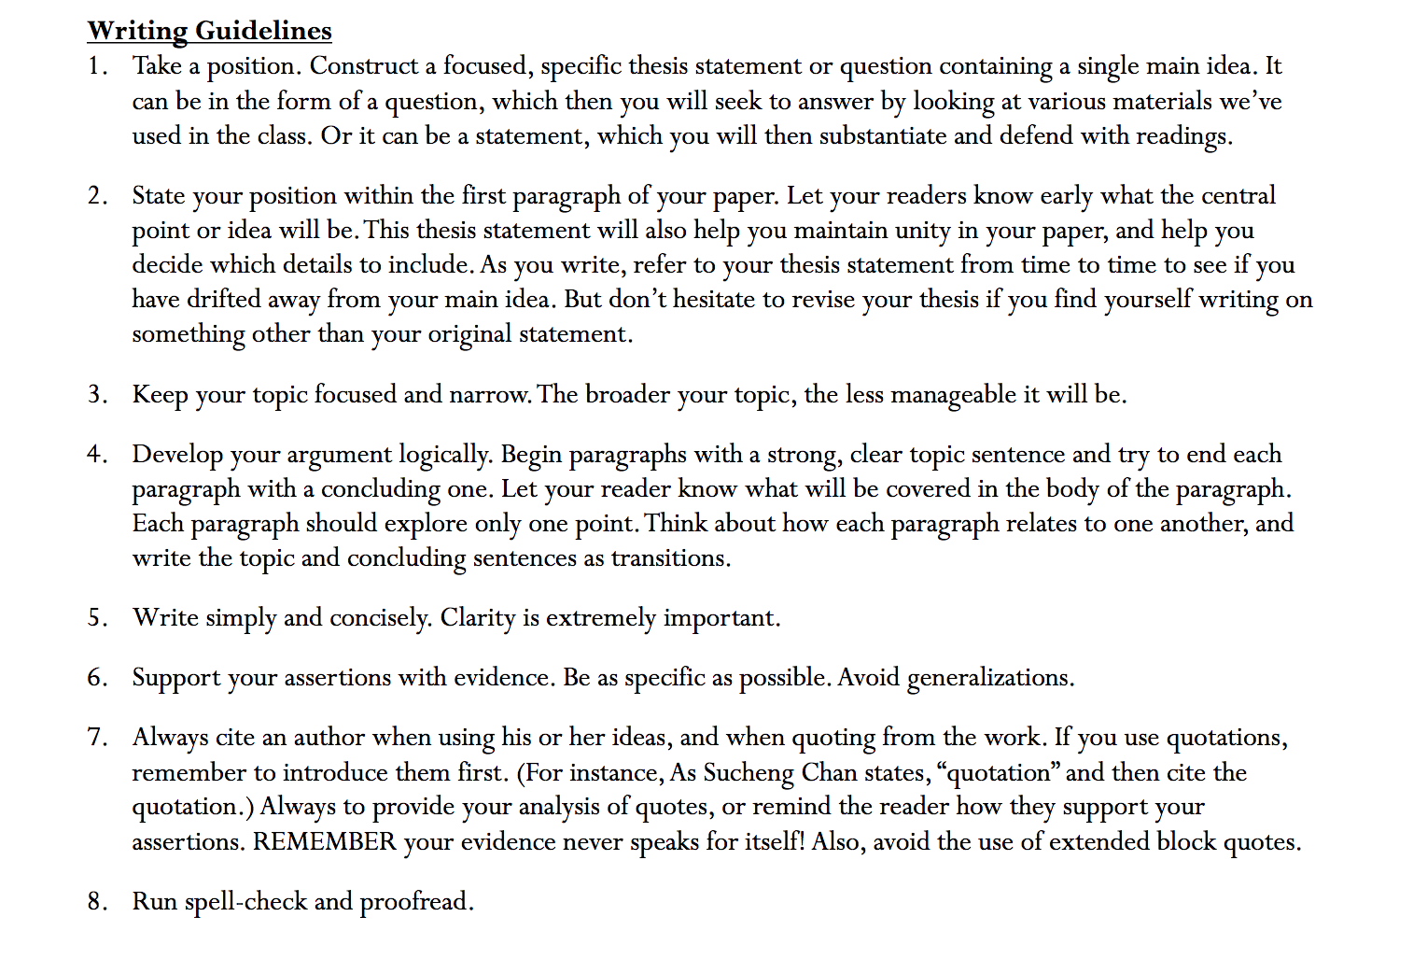
Here are points that you must read

To make it clear,

For point 1, please read it because the instruction is clear already.
For point 2, it says that for your first paragraph, please make a thesis that is the central of the paper, so your audience knows the points you will deliver. Again it is not a summary, but your analysis/ argument toward the prompt.
For point 3, sometimes your points are too broad. Please make it more specific by being more critical.
For point 4, as I tell you that please begin the paragraph with a clear topic sentence. EACH PARAGRAPH SHOULD ONLY EXPLORE ONE POINT. Most of your paragraph was too short, which made them not strong enough to convince or persuade the readers. Again, each paragraph consists of a clear topic sentence, your reason, and backed up with at least one piece of evidence from the reading. The reading purpose’s just to support your argument by telling the evidence. Please do not need to summarize the reading or telling what happens in the reading. Instead, you suppose to give analysis or argument about the prompt and show that the reading also supports your argument. This is graded on how you able to convince/ persuade your readers about your analysis toward the prompt.
For point 6, avoid generalization. Your paper #1 was too broad, and they were most summary, not analysis.For point 7, see how to quote and avoid the use of extended block quotes. “Do not organize your paper according to the readings you are using, but rather by the larger themes of your argument.”
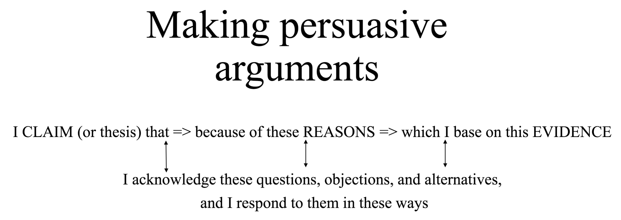

Here is the feedback from my professor regarding Short Writing Assignment 2, which the issues in SWA#2 are just the same as your issues in Paper#2:

"Your paper seems to focus a lot on summarizing details, mainly those of the Flora Belle Jan reading. You don't get to the argument until the end of your first page and into your second page. Your first paragraph goes right into Flora Belle Jan, but does not establish your argument for the remainder of the paper.

If I were you, I would focus on revising to have less description of examples and more analysis. Organize the paper so that the reader knows exactly what your argument is at the very beginning of the paper, within the first paragraph. Do not organize your paper according to the readings you are using, but rather by the larger themes of your argument."

For the illustration, so you know the concept of this paper:

